What is Virtualization?
Virtualization means creating a virtual version of a computer system using software.
Instead of using one physical computer for only one operating system, virtualization allows a single physical machine to run multiple virtual computers.
Each virtual computer behaves like a real computer.
Example:
One powerful server can run:
- Windows VM
- Ubuntu VM
- Kali Linux VM
all at the same time.

Simple Idea
Without virtualization:
- 1 server → 1 operating system
With virtualization:
- 1 server → many virtual machines (VMs)

Visualization of Virtualization
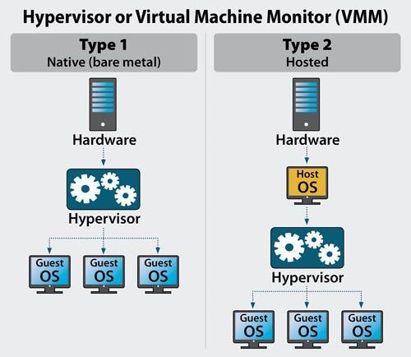

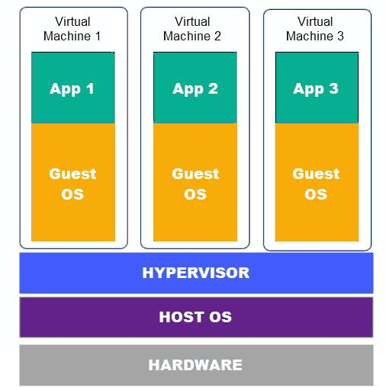

What is a VM (Virtual Machine)?
A VM is a software-based computer.
It has:
- Virtual CPU
- Virtual RAM
- Virtual Storage
- Virtual Network
Just like a real computer.
You can install operating systems inside it.
Examples:
- Ubuntu VM
- Windows 11 VM
- Linux Server VM

What is a Hypervisor?
A Hypervisor is software that creates and manages Virtual Machines.
It controls:
- CPU allocation
- Memory allocation
- Storage
- Networking
Think of it as a manager between hardware and virtual machines.

Hypervisor Working
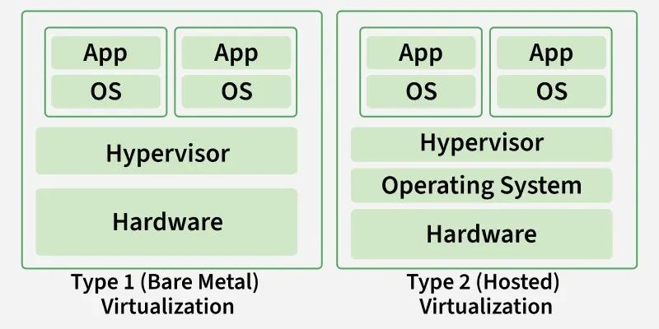

Types of Hypervisor

1. Bare-Metal Hypervisor (Type 1)
Installed directly on hardware.
No normal operating system is required.

Used By
- Cloud providers
- Data centers
- Enterprise servers

Advantages
- Very fast
- More secure
- Better performance
- Handles many VMs

Examples
- VMware ESXi
- Microsoft Hyper-V
- Xen

2. Hosted Hypervisor (Type 2)
Installed on top of a normal operating system.

Working
Hardware → Host OS → Hypervisor → VM

Used For
- Personal learning
- Testing
- Development

Advantages
- Easy to install
- Beginner friendly

Examples
- Oracle VM VirtualBox
- VMware Workstation
- Parallels Desktop

Hosted Hypervisor Diagram

Why Do Companies Use Virtualization?
Companies use virtualization because it saves:
- Money
- Space
- Electricity
- Hardware cost
and improves:
- Flexibility
- Scalability
- Security

Main Use Cases of Virtualization

1. Cloud Computing
Cloud providers like:
- Amazon Web Services
- Microsoft
- Google
run thousands of VMs on huge servers.

2. Software Testing
Developers test apps on:
- Windows
- Linux
- Different versions
without buying multiple computers.

3. Running Old Software
Old operating systems can run inside VMs.
Example:
- Windows XP inside a VM on Windows 11.

4. Server Consolidation
Instead of:
- 10 physical servers
companies use:
- 1 powerful server + 10 VMs

5. Cybersecurity & Ethical Hacking
Security researchers use VMs to:
- Test malware
- Practice hacking labs safely
Example:
- Kali Linux VM

Benefits of Virtual Machines (VMs)

1. Better Resource Utilization
One physical server can do many tasks.

2. Cost Saving
Less hardware required.

3. Isolation
If one VM crashes, others are safe.

4. Easy Backup & Recovery
VM snapshots can restore systems quickly.

5. Scalability
New VMs can be created quickly.

6. Portability
VMs can move from one server to another.

Real-Life Example
Suppose a company has:
- HR software
- Database server
- Website server
Instead of buying 3 separate computers:
They use:
- 1 powerful server
- 3 separate VMs
This reduces:
- Electricity usage
- Cooling cost
- Hardware maintenance

What is Cloud Computing?
Cloud computing means using computing services over the internet instead of owning and managing physical computers yourself.
These services include:
- Servers
- Storage
- Databases
- Networking
- Software
- AI tools
Instead of buying a powerful computer/server, companies rent resources from cloud providers whenever needed.

Simple Definition
“Cloud computing is the delivery of computing services over the internet.”

Cloud Computing Visualization
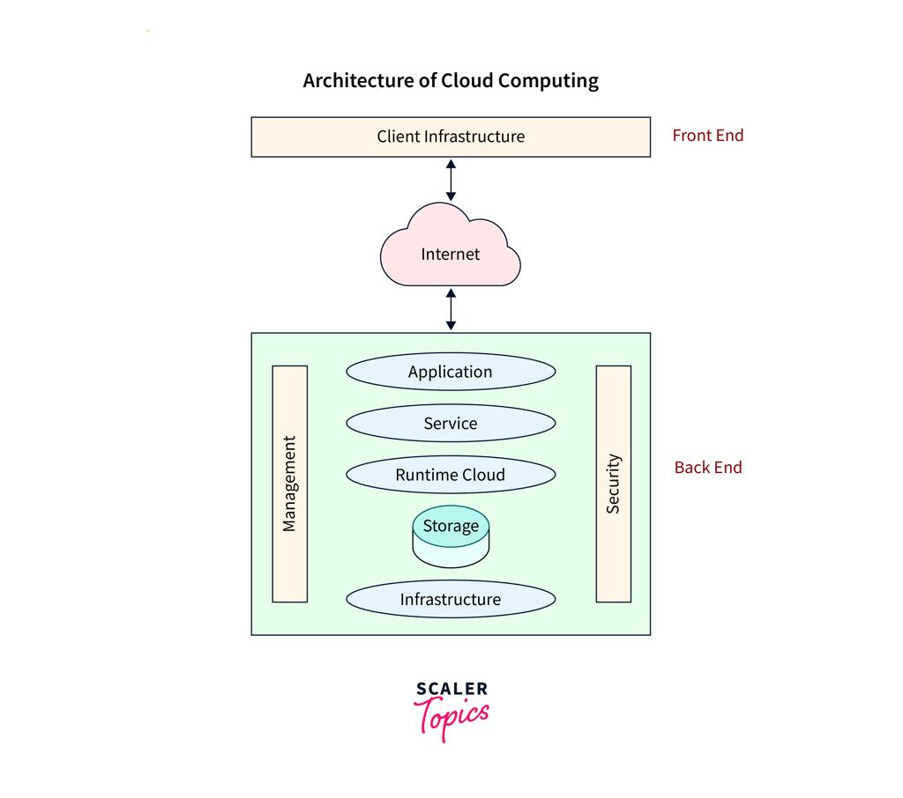
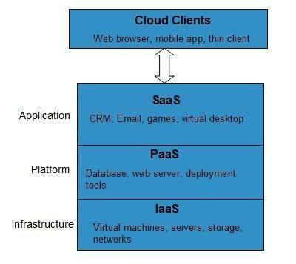

Examples of Cloud Computing Platforms
Major cloud providers:
- Amazon Web Services (AWS)
- Microsoft (Azure)
- Google (GCP)
Other examples:
- DigitalOcean
- Oracle
- IBM

How Cloud Computing Works
Cloud providers have huge data centers containing:
- Thousands of servers
- Networking devices
- Storage systems
Users access these resources through the internet.
Example:
When you open:
- Google Drive
- Netflix
- AWS server
you are using cloud infrastructure.

Working of Cloud Computing

Step-by-Step
- User sends request through internet
- Cloud provider receives request
- Resources are allocated automatically
- Service is delivered
- User pays only for usage

Why Cloud Computing is Beneficial

1. Cost Saving
No need to buy expensive servers.

2. Scalability
Increase or decrease resources anytime.
Example:
- During sale season, an e-commerce app can increase servers.

3. High Availability
Cloud providers maintain backup systems.

4. Access Anywhere
Use services from any location.

5. Faster Development
Developers deploy applications quickly.

6. Security
Cloud providers offer advanced security tools.

Traditional vs Cloud Computing
Feature | Traditional Computing | Cloud Computing
Hardware | Own physical servers | Rent servers online
Cost | High initial cost | Pay as you use
Scalability | Slow | Fast
Maintenance | Company manages | Cloud provider manages
Availability | Limited | Very high
Setup Time | Days/weeks | Minutes

Types of Cloud Computing Services
There are 3 main models:
- IaaS
- PaaS
- SaaS

Best Analogy for IaaS, PaaS, SaaS
Think about making and selling food.

1. IaaS (Infrastructure as a Service)
You rent:
- Kitchen
- Gas
- Tables
- Building
But YOU cook food yourself.
Cloud provider gives:
- Virtual machines
- Storage
- Networking
You manage:
- OS
- Applications
- Data

Examples
- Amazon Web Services EC2
- Google Compute Engine

IaaS Diagram
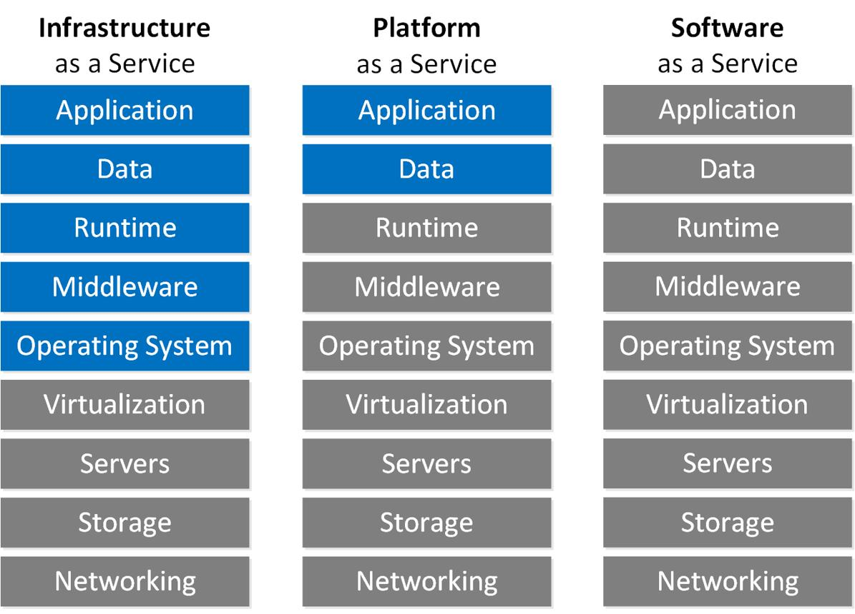
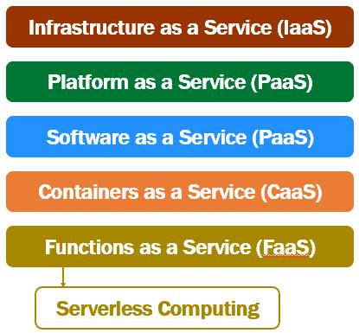

2. PaaS (Platform as a Service)
Kitchen + tools + environment already prepared.
You only cook food.
Cloud provider manages:
- Servers
- OS
- Runtime
You only deploy code.

Examples
- Google
- Microsoft

PaaS Diagram
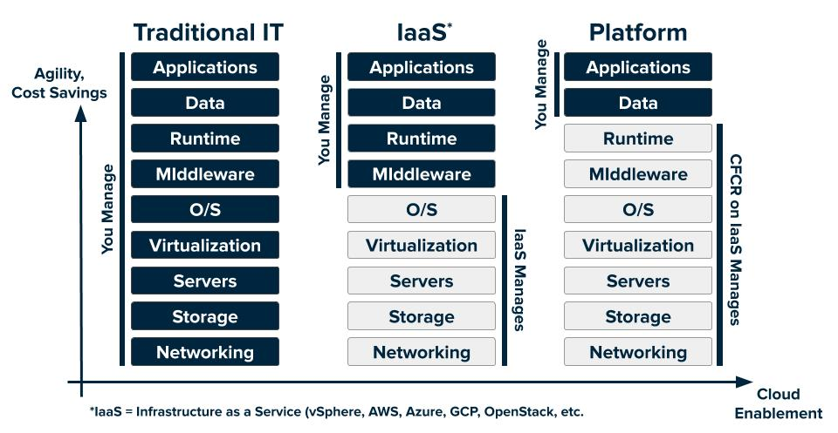

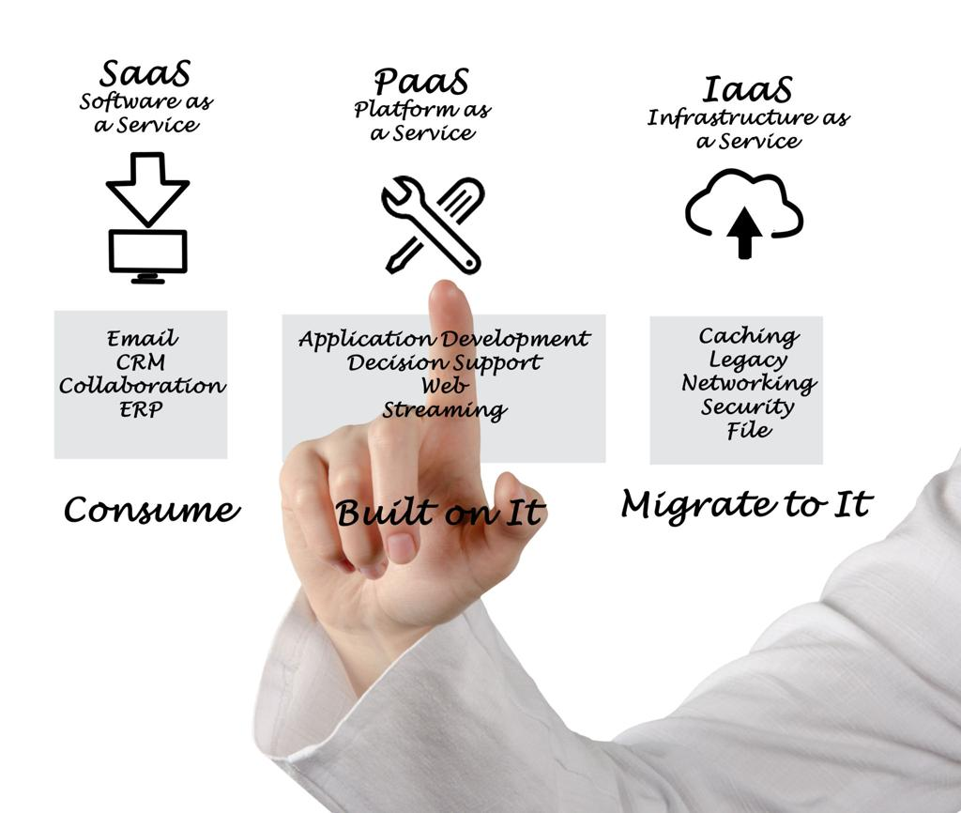

3. SaaS (Software as a Service)
Ready-made food.
You just eat.
Everything managed by provider.
Users simply use software through internet.

Examples
- Google
- Microsoft
- Zoom Video Communications

SaaS Diagram
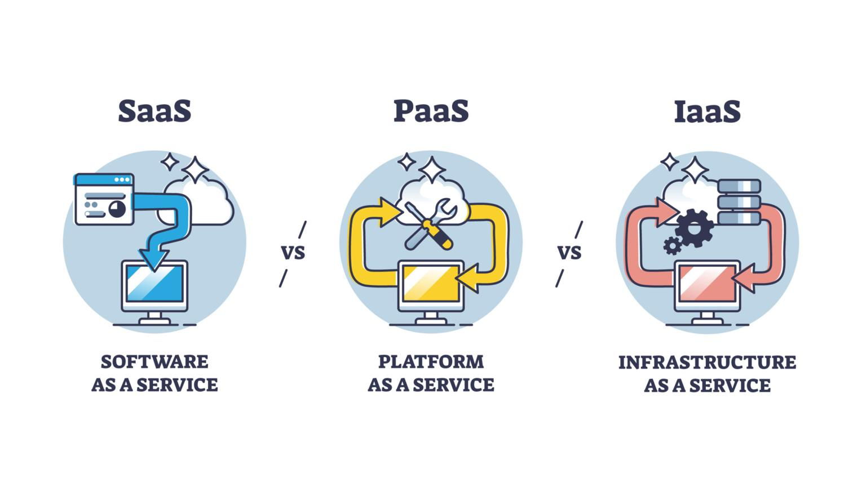

Quick Comparison of IaaS vs PaaS vs SaaS
Feature | IaaS | PaaS | SaaS
Control | Highest | Medium | Lowest
Managed By User | Most things | Only app/code | Almost nothing
Used By | System admins | Developers | End users
Example | EC2 | App Engine | Gmail

Types of Cloud Platforms
There are 3 deployment models:
- Public Cloud
- Private Cloud
- Hybrid Cloud

1. Public Cloud
Cloud resources shared over internet.
Anyone can rent them.

Examples
- AWS
- Azure
- Google Cloud

Analogy
Like staying in a hotel:
- Shared building
- Separate rooms

2. Private Cloud
Cloud infrastructure dedicated to one organization.

Used By
- Banks
- Government
- Military

Analogy
Like owning a private house.

Example
A bank's internal cloud servers.

. Hybrid Cloud
Combination of:
- Public cloud
- Private cloud

Analogy
Private house + hotel combination.
Sensitive work stays private, other work goes public.

Example
A company stores confidential data privately but hosts website on AWS.

Features / Services of Cloud Computing

1. Compute Services
Provide virtual computers/servers.

Examples
- AWS EC2
- Azure Virtual Machines
Used to:
- Run applications
- Host websites

2. Storage Services
Store files and data.

Examples
- AWS S3
- Google Cloud Storage
Used for:
- Photos
- Videos
- Backups

3. Database Services
Managed databases in cloud.

Examples
- AWS RDS
- Firebase
Used for:
- App user data
- Transactions

4. Networking Services
Connect cloud resources securely.

Examples
- Virtual networks
- Load balancers
- DNS

5. Container Services
Run applications in containers.

Examples
- Docker
- Kubernetes
Used for:
- Microservices
- Scalable apps

6. Serverless Services
Run code without managing servers.
Cloud automatically handles infrastructure.

Examples
- AWS Lambda
- Google Cloud Functions
You upload code → cloud runs it.

7. Machine Learning Services
Cloud-based AI/ML tools.

Examples
- Google Vertex AI
- AWS SageMaker
Used for:
- Chatbots
- Recommendations
- Image recognition

8. IAM (Identity and Access Management)
Controls:
- Who can access resources
- What permissions they have

Example
Admin can:
- Create servers
Normal employee can:
- Only view reports
IAM improves security.

IAM Diagram
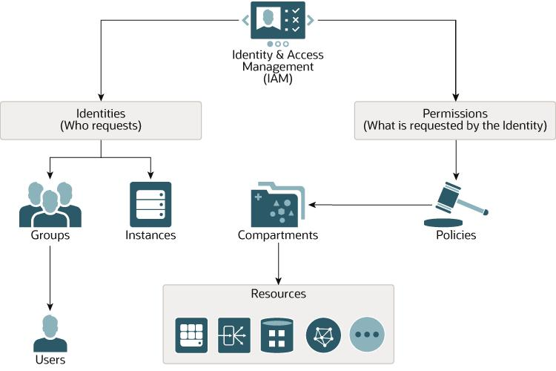
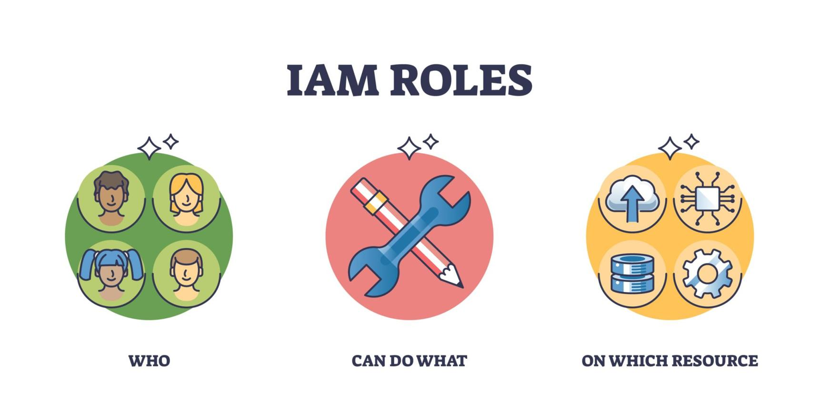Real-Life Example
Suppose you create a food delivery app.
You may use:
- Compute → run backend
- Storage → save images
- Database → store users/orders
- IAM → manage admin access
- Serverless → send OTP
- ML → recommend foods
All from cloud providers.

What is AWS?
Amazon Web Services (AWS) is a cloud computing platform provided by Amazon.
It allows people and companies to:
- Rent servers
- Store data
- Run applications
- Use databases
- Deploy AI/ML models
- Manage networking
through the internet instead of buying physical infrastructure.
AWS is the world's most widely used cloud platform.

AWS Visualization
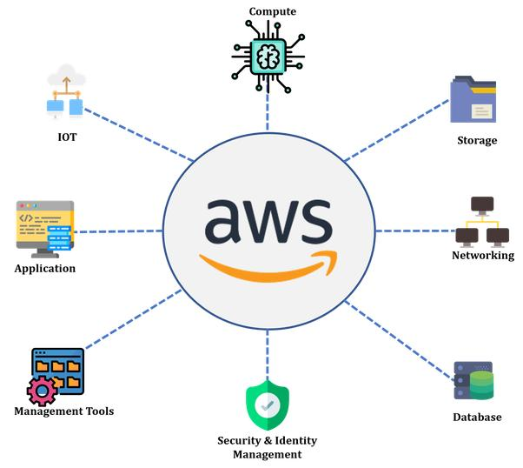

How AWS Works
AWS owns huge data centers around the world.
These data centers contain:
- Servers
- Storage systems
- Networking devices
- Security systems
When users need resources:
- They log into AWS
- Choose services
- AWS allocates resources virtually
- Users access them through internet
Example:
You can create a virtual Linux server in minutes using EC2.

Pay-As-You-Go Model
AWS follows a Pay-As-You-Go pricing model.
Meaning:
- Pay only for what you use
- No need to buy expensive hardware

Simple Example
Suppose:
- You use a server for 5 hours
- AWS charges ₹10/hour
You pay:
- ₹50 only
If you stop the server:
- Billing stops
This makes AWS cost-efficient.

Analogy
Like electricity billing:
- Use more → pay more
- Use less → pay less

How Many Services Does AWS Provide?
AWS provides 200+ cloud services.
These services cover:
- Computing
- Storage
- Databases
- Networking
- Security
- AI/ML
- Analytics
- IoT
- DevOps
- Containers

Popular AWS Services
Service | Purpose
EC2 | Virtual servers
S3 | Cloud storage
RDS | Managed databases
Lambda | Serverless computing
IAM | Access control
VPC | Virtual networking
CloudFront | CDN
ECS/EKS | Containers
DynamoDB | NoSQL database
SageMaker | Machine learning

Popular AWS Services Visualization
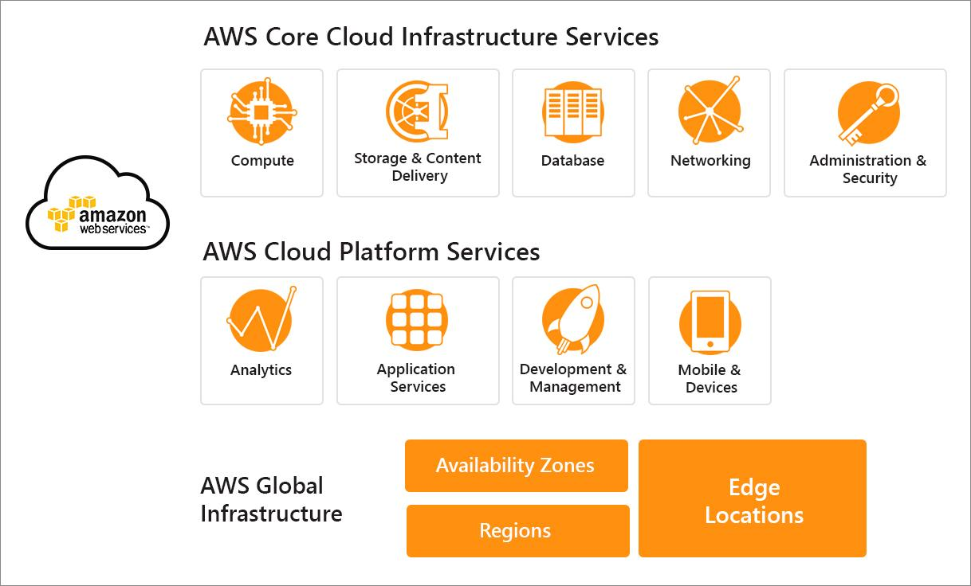

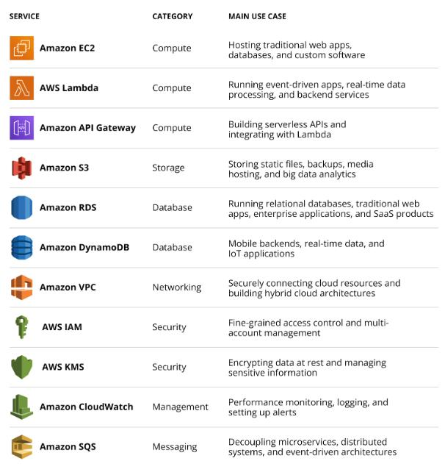

Why is AWS So Famous?

1. Scalability
AWS can increase or decrease resources instantly.
Example:
- During Amazon sale events, servers automatically scale up.
This is called auto scaling.

2. Global Reach
AWS has data centers across many countries.
This helps:
- Faster speed
- Low latency
- Better user experience

AWS Global Infrastructure
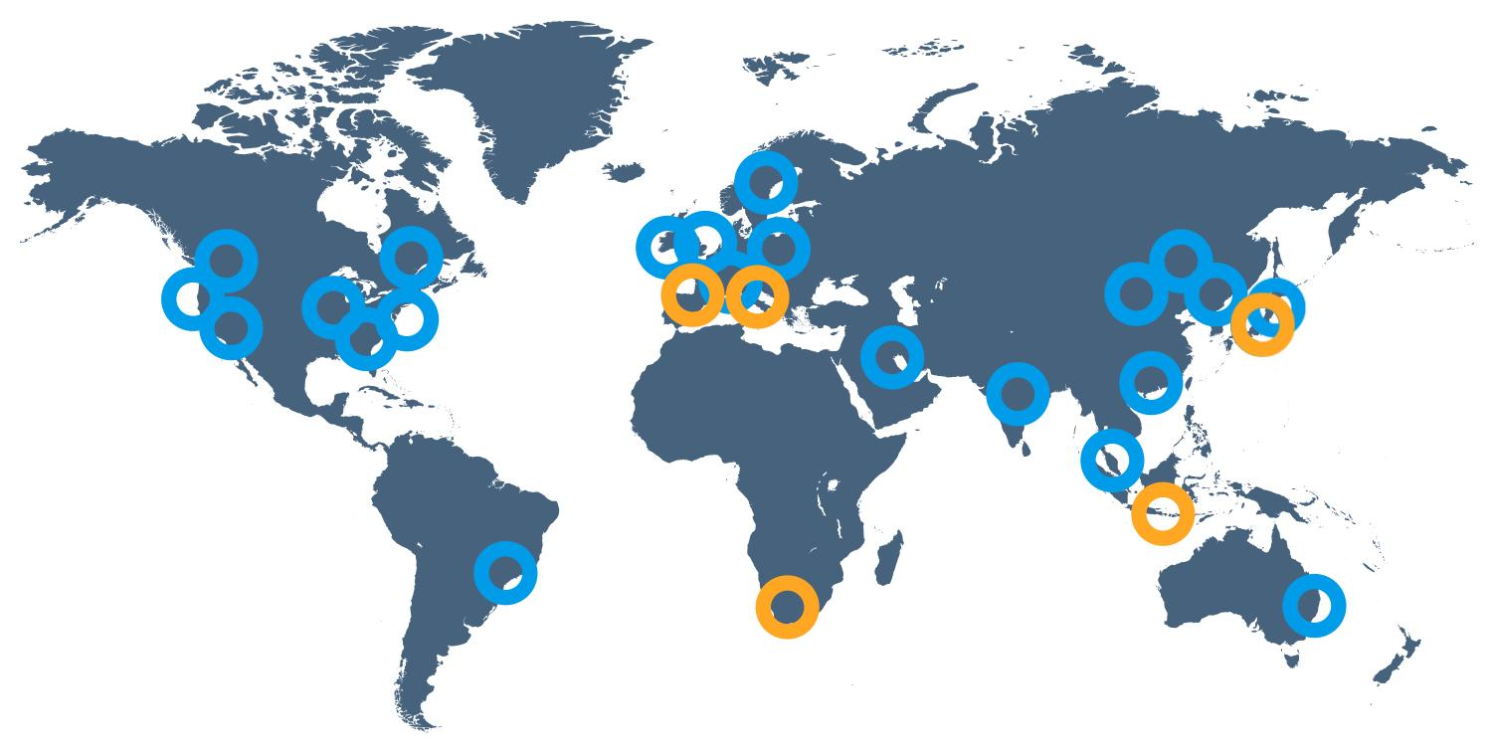
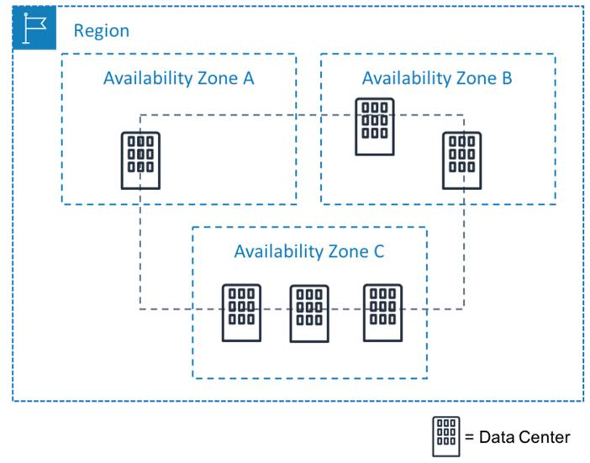
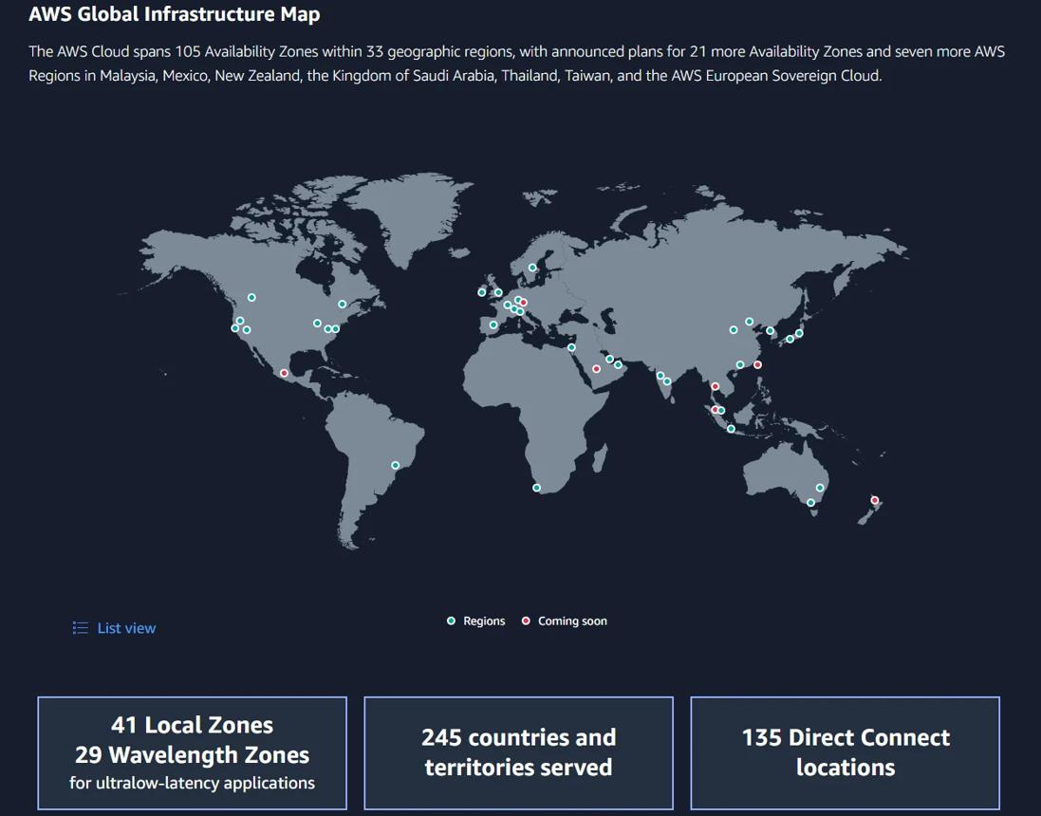

3. Reliability
AWS provides:
- Backup systems
- Disaster recovery
- Redundant infrastructure
Applications remain online even if one server fails.

4. Security
AWS provides:
- Encryption
- IAM access control
- Firewalls
- Security monitoring
Even governments and banks use AWS.

5. Huge Service Ecosystem
AWS provides almost everything needed for modern applications.

6. Trusted by Large Companies
Many companies use AWS because it is stable and mature.

Companies Using AWS
Examples:
- Netflix
- Airbnb
- Spotify
- NASA
- Adobe

AWS Market Share
AWS is the largest cloud provider globally.
Approximate cloud market share:
Cloud Provider | Market Share
AWS | ~30%
Microsoft Azure | ~20–25%
Google Cloud | ~10–12%
Others | Remaining
AWS still leads the market globally.

What is an Availability Zone (AZ)?
An Availability Zone is a separate physical data center inside an AWS Region.
Each region contains multiple AZs.
Example:
- Mumbai Region may have multiple AZs.
Purpose:
- High availability
- Fault tolerance
If one AZ fails:
- Another AZ continues running applications.

Region vs Availability Zone
Term | Meaning
Region | Geographic location
Availability Zone | Individual isolated data center

AWS Career Roles
After learning AWS, many roles are available.

Beginner Roles
Role | Work
Cloud Support Associate | Help customers manage cloud
AWS Administrator | Manage AWS infrastructure
Junior Cloud Engineer | Deploy cloud resources
DevOps Intern | CI/CD and automation

Intermediate Roles
Role | Work
Cloud Engineer | Build cloud systems
DevOps Engineer | Automation & deployment
Site Reliability Engineer (SRE) | Reliability & monitoring
Systems Engineer | Server/network management
Infrastructure Engineer | Cloud infrastructure

Advanced Roles
Role | Work
Solutions Architect | Design cloud architecture
Cloud Architect | Enterprise cloud design
Security Engineer | Cloud security
Data Engineer | Big data pipelines
Machine Learning Engineer | AI/ML systems
Kubernetes Engineer | Container orchestration
Platform Engineer | Internal cloud platforms

Specialized AWS Roles
Role | Focus
AWS Security Specialist | Security
AWS Networking Specialist | Networking
AWS Database Engineer | Databases
FinOps Engineer | Cloud cost optimization
Cloud Consultant | Business cloud solutions

DevOps + AWS Combination
One of the most demanded combinations is:
- AWS + Linux + Docker + Kubernetes + CI/CD
Used heavily in:
- Startups
- Product companies
- Enterprises

AWS Certifications
Popular certifications:
Certification | Level
AWS Cloud Practitioner | Beginner
AWS Solutions Architect Associate | Intermediate
AWS Developer Associate | Intermediate
AWS SysOps Administrator | Intermediate
AWS DevOps Engineer Professional | Advanced

Real-Life Example
Suppose you build a food delivery app.
You can use:
- EC2 → Backend server
- S3 → Store images
- RDS → Database
- Lambda → OTP sending
- CloudFront → Faster delivery
- IAM → User permissions
All inside AWS.

What is AWS Identity and Access Management (IAM) ?
IAM is a service in AWS used to:
- Control who can access AWS
- Control what they can do
- Provide secure login and permissions
It is basically the security and permission management system of AWS.
Example:
- Your company has developers, testers, admins.
- Not everyone should access everything.
- IAM lets you decide:
  - who can log in
  - which services they can use
  - what actions they can perform

Features of IAM

1. Free Service
IAM itself is free.
You are not charged for:
- creating users
- groups
- roles
- policies
(You only pay for other AWS services like EC2, S3, etc.)

2. Global Service
IAM is a global service.
That means:
- It works across all AWS regions.
- Create a user once → user can access resources in multiple regions.
Example:
- Mumbai region
- US East region
- Europe region
Same IAM user can work everywhere if permissions are given.

What Can We Do in IAM?

1. Create Users
A user is an individual person/account inside AWS.
Example:
- Vinit
- Developer1
- Tester1
Each user gets:
- username
- password
- access keys (optional)

Steps
- Open AWS Console
- Search IAM
- Users
- Create User
- Enter username
- Give console access if needed
- Attach permissions
- Create user

2. Create Groups
A group is a collection of users.
Example:
- Developers group
- Testers group
- Admins group
Instead of assigning permissions one-by-one, assign to group.

Example
Developers group gets:
- EC2 access
- S3 access
All users inside group automatically get same permissions.

Steps
- IAM → User Groups
- Create Group
- Give group name
- Attach policies
- Add users

3. Assign Permissions
Permissions decide:
- what user can do
- what user cannot do
Example:
- Start EC2
- Stop EC2
- Read S3 bucket
- Delete database
Permissions are given using:
- Policies

4. Define Policies
Policies are JSON documents containing rules.
Example policy:
{
"Effect": "Allow",
"Action": "s3:ListBucket",
"Resource": "*"
}
Meaning:
- Allow listing S3 buckets.

Types
- AWS Managed Policies
- Customer Managed Policies
- Inline Policies

5. Manage Federated Access
Federated access means:
users can log in using:
- Google
- Facebook
- Company login
- Active Directory
instead of creating separate IAM users.
Example:
- Employee logs in using company credentials.
This is useful for:
- enterprises
- large organizations

6. Create Roles
A role provides temporary permissions.
Roles are used by:
- AWS services
- applications
- EC2 instances
- Lambda functions
Example:
EC2 instance needs access to S3.
Instead of storing passwords:
- attach IAM role to EC2.
More secure.

What is MFA in AWS?
MFA = Multi-Factor Authentication
It adds extra security.
Login requires:
- Password
- OTP code from phone/app
So even if password is stolen, account stays protected.

MFA for Root User
Root user = main AWS account owner.
This account has:
- full access
- highest permissions
AWS strongly recommends enabling MFA for root user.
Because:
if hacker gets root access → entire AWS account can be controlled.

How Root User MFA Works
When logging in:
- Enter email/password
- Enter OTP from authenticator app
OTP changes every 30 seconds.
Apps:
- Google Authenticator
- Microsoft Authenticator

Steps to Enable MFA for Root User
- Login as root user
- Click account name (top right)
- Security Credentials
- MFA
- Assign MFA Device
- Choose Authenticator App
- Scan QR code
- Enter two OTPs
- Finish setup

Ways of Accessing AWS Services
There are multiple ways:

1. AWS Management Console (GUI Mode)
This is the graphical website interface.
Website:
AWS Management Console
You click buttons and menus.

Used By
- beginners
- admins
- manual work

Advantages
- easy to use
- no coding needed
- visual interface

Disadvantages
- slow for automation
- repetitive work is difficult

2. AWS CLI (Command Line Interface)
CLI lets you control AWS using terminal commands.
Example:
aws s3 ls
Lists S3 buckets.

Used By
- DevOps engineers
- automation
- scripting

Advantages
- fast
- automation possible
- powerful

Disadvantages
- commands must be learned

3. AWS SDK
SDK = Software Development Kit
Used inside programming languages.
Available for:
- Python
- Java
- Node.js
- C++
- Go
Example in Python:
import boto3
s3 = boto3.client('s3')

Used For
Applications interacting with AWS.
Example:
- upload file to S3 from website

Advantages
- full programmatic control
- integration with apps

Disadvantages
- coding knowledge needed

4. AWS API
AWS services internally expose APIs.
CLI and SDK actually use APIs behind the scenes.
Example:
- Send HTTP request to AWS endpoint.

Used By
- advanced integrations
- custom tools

Difference Between Console, CLI, SDK, API
Feature | Console (GUI) | CLI | SDK | API
Interface | Graphical | Terminal | Programming | HTTP Requests
Easy for beginners | Yes | Medium | No | No
Automation | Limited | Good | Excellent | Excellent
Coding needed | No | Little | Yes | Yes
Speed | Slower | Fast | Fast | Fastest
Best for | Learning/manual tasks | DevOps | App development | Advanced systems

AWS IAM Best Practices
These are important security rules recommended in AWS.

1. Avoid Using Root Account Except for Initial Setup

What is Root Account?
Root account is the main AWS account created using:
- email
- password
It has:
- complete control over AWS

Why avoid using it daily?
If root account gets hacked:
- entire AWS account becomes compromised.
So:
- use root only for important account-level tasks.

Use Root Only For
- changing billing settings
- closing account
- enabling MFA
- initial setup

Best Practice
✅ Create IAM users for daily work.
❌ Do not use root for normal tasks.

2. Add Users to Groups and Assign Permissions to Groups
Instead of:
- giving permissions individually to every user,
AWS recommends:
- create groups
- assign permissions to groups

Example

Group:
Developers

Permissions:
- EC2 access
- S3 access

Users:
- Vinit
- Rahul
- Aman
Add users to Developers group.
All users automatically get permissions.

Advantages
✅ Easier management
✅ Better organization
✅ Reduces mistakes
✅ Scalable

Steps
- IAM
- User Groups
- Create Group
- Attach policies
- Add users

3. Use Password Policy or MFA

Password Policy
Password policy forces strong passwords.
Example rules:
- minimum 8 characters
- uppercase required
- numbers required
- special characters required

MFA (Multi-Factor Authentication)
MFA adds:
- second security layer
Login requires:
- Password
- OTP from phone/app

Why Important?
Even if password is stolen:
- hacker still cannot login without OTP.

Best Practice
✅ Enable MFA for:
- root user
- IAM users

4. Use Access Keys for CLI/SDK
When using:
- AWS CLI
- SDK
- automation scripts
You use:
- Access Key ID
- Secret Access Key
instead of password.

Example
CLI command:
aws configure
Then enter:
- Access Key ID
- Secret Access Key
- region
- output format

Why Needed?
CLI and SDK cannot use GUI passwords directly.
They authenticate using access keys.

Best Practice
✅ Create separate access keys for users/apps.
❌ Never use root account access keys.

5. Never Share Access Keys or Passwords
Access keys are like:
- secret passwords for programs.
If leaked:
- attacker can control AWS resources.

Never:
❌ Share on WhatsApp
❌ Upload to GitHub
❌ Put inside public code
❌ Send in screenshots

Best Practice
✅ Store securely
✅ Rotate keys regularly
✅ Delete unused keys

6. Audit Permissions Using IAM Credential Report
IAM Credential Report is a security report.
It shows:
- users
- passwords
- MFA enabled or not
- access keys age
- last login time

Why Important?
Helps identify:
- unused users
- weak security
- old access keys
- users without MFA

Steps to Generate Credential Report
- Open IAM
- Credential Report
- Download Report

Example Information in Report
User | MFA Enabled | Password Used | Access Key Age
Vinit | Yes | Recently | 20 days
TestUser | No | Never | 400 days

AWS EC2 (Elastic Compute Cloud) — Complete Beginner Guide

What is EC2 in AWS?
Amazon Web Services EC2 (Elastic Compute Cloud) is a cloud service that lets you create virtual computers (servers) on the internet.
You can:
- Host websites
- Run applications
- Store files
- Run databases
- Practice Linux
- Deploy backend/frontend projects
- Run AI/ML workloads
Think of EC2 as:
“Renting a computer from AWS.”
You choose:
- CPU
- RAM
- Storage
- Operating system
- Security
- Region
and AWS gives you a running server within minutes.

Real-Life Use Cases of EC2

Small Website or Blog
Use:
- t3.micro
- t3.small
Why?
- Cheap
- Low traffic handling
- Free-tier friendly
Examples:
- Portfolio website
- Blog
- Small Node.js app

E-Commerce Application
Use:
- m5.large
- m5.xlarge
Why?
- Balanced CPU + RAM
- Good for backend + database workloads
Examples:
- Shopping websites
- Payment systems
- Medium business applications

Real-Time Video Rendering / Streaming
Use:
- g5.12xlarge
- g5.24xlarge
Why?
- GPU accelerated
- Fast graphics/video processing
Examples:
- Video rendering
- Streaming servers
- AI image generation

In-Memory Analytics Database
Use:
- r6g.16xlarge
- x2idn.32xlarge
Why?
- Huge RAM
- Very fast memory access
Examples:
- Redis
- SAP HANA
- Analytics engines

Important EC2 Terms

1. Instance Type
Instance Type = Hardware configuration of the virtual machine.
It defines:
- CPU
- RAM
- Network speed
- GPU
Examples:
Instance | Use
t3.micro | Small apps
m5.large | Balanced workloads
c5.large | CPU intensive
r5.large | Memory intensive
g5.large | GPU workloads

2. AMI (Amazon Machine Image)
AMI = Template used to create EC2.
It contains:
- Operating System
- Installed software
- Configurations
Examples:
- Ubuntu AMI
- Amazon Linux AMI
- Windows Server AMI
Think:
AMI = Ready-made OS image

3. Storage
EC2 storage mainly uses:

EBS (Elastic Block Store)
Persistent hard disk.
Used for:
- OS
- Files
- Databases
Even if instance stops:
- Data remains

Instance Store
Temporary storage.
If instance stops/terminates:
- Data may disappear
Used for:
- Cache
- Temporary processing

4. Security Groups
Security Group = Virtual Firewall for EC2.
Controls:
- Who can enter
- Who can leave

Inbound Traffic
Traffic COMING INTO server.
Examples:
- User opening website
- SSH login request
Example Rules:
Protocol | Port | Purpose
HTTP | 80 | Website
HTTPS | 443 | Secure Website
SSH | 22 | Linux login
RDP | 3389 | Windows login

Outbound Traffic
Traffic GOING OUT from server.
Examples:
- Server downloading updates
- Server calling APIs
By default:
- All outbound allowed

Important Security Group Points
Based on your image:
- Security groups are Region specific
- Only ALLOW rules
- No DENY rule
- All inbound blocked by default
- All outbound allowed by default
You can define rules using:
- Protocols
- Port numbers
- IP addresses
Important:
If inbound traffic is allowed on a port, the response traffic automatically works without adding outbound rule manually.

5. Key Pair
Used for secure login into EC2.
Contains:
- Public key (stored in AWS)
- Private key (stored with you)
Examples:
- .pem
- .ppk
Linux SSH:
ssh -i mykey.pem ubuntu@PUBLIC_IP
Windows PuTTY:
- Convert .pem → .ppk

6. Network Settings
Controls networking.
Includes:
- VPC
- Subnet
- Public IP
- Internet access
Important:
If instance needs internet:
- Public IP required
- Internet Gateway required

7. IAM Role
IAM Role gives permissions to EC2.
Example:
Allow EC2 to:
- Access S3
- Access DynamoDB
- Send logs to CloudWatch
Without storing passwords/access keys manually.

8. User Data
Startup script executed automatically when EC2 launches.
Used for:
- Installing software
- Running commands automatically
Example:
#!/bin/bash
apt update -y
apt install nginx -y
systemctl start nginx
systemctl enable nginx
echo "<h1>Hello from EC2</h1>" > /var/www/html/index.html
This automatically:
- Installs Nginx
- Starts web server
- Creates webpage

Is EC2 Paid?
YES.
EC2 is mostly paid based on:
- Running time
- Storage
- Data transfer

Free Tier
AWS provides free tier for beginners.
Usually includes:
- t2.micro or t3.micro
- Limited monthly hours
- Limited storage
If you exceed limits:
- Charges apply

EC2 Cost Depends On
- Instance type
- Region
- Storage size
- Running hours
- Data transfer
Powerful instances cost more.
Example:
- t3.micro = cheap
- g5.24xlarge = very expensive

Is EC2 Region Specific?
YES.
EC2 instances are REGION specific.
Example:
- Mumbai region
- Virginia region
- Singapore region
Resources belong to selected region.

Are All AWS Services Region Specific?
NO.
Some are:
- Global services
- Region-specific services

Global Services
Examples:
- IAM
- Route 53
- CloudFront
Available globally.

Region-Specific Services
Examples:
- EC2
- RDS
- VPC
- EBS
Created inside a region.

Common Protocols and Port Numbers
Protocol | Port | Purpose
HTTP | 80 | Website
HTTPS | 443 | Secure website
SSH | 22 | Linux remote login
FTP | 21 | File transfer
SFTP | 22 | Secure file transfer
SMTP | 25 | Sending emails
RDP | 3389 | Windows remote desktop
MySQL | 3306 | MySQL database
PostgreSQL | 5432 | PostgreSQL database
DNS | 53 | Domain name resolution

HTTP vs HTTPS

HTTP
- Not encrypted
- Less secure
- Port 80

HTTPS
- Encrypted using SSL/TLS
- Secure
- Port 443

SSH
Secure Shell.
Used to:
- Login remotely into Linux server
Example:
ssh ubuntu@ip-address

FTP
File Transfer Protocol.
Used for:
- Upload/download files
Not secure.

SFTP
Secure FTP over SSH.
Encrypted and secure.

SMTP
Used for sending emails.

RDP
Remote Desktop Protocol.
Used for:
- Connecting Windows server GUI remotely

DNS
Converts:
- Domain → IP address
Example:
google.com → 142.x.x.x

How To Create EC2 Instance (Step-by-Step)

Step 1
Login to AWS Console.

Step 2
Search:
EC2

Step 3
Click:
Launch Instance

Step 4
Enter:
Instance Name

Step 5
Choose AMI
Example:
Ubuntu Server 24.04

Step 6
Choose Instance Type
Example:
t3.micro

Step 7
Create/Select Key Pair
Download:
mykey.pem
Keep it safe.

Step 8
Configure Network Settings
Allow:
- SSH (22)
- HTTP (80)
- HTTPS (443)

Example Security Group Rules
Type | Port | Source
SSH | 22 | My IP
HTTP | 80 | Anywhere
HTTPS | 443 | Anywhere

Step 9
Configure Storage
Example:
8 GB

Step 10
(Optional) Add User Data Script
Example:
#!/bin/bash
apt update -y
apt install nginx -y
systemctl start nginx
echo "<h1>Hello EC2</h1>" > /var/www/html/index.html

Step 11
Click:
Launch Instance
Done.

How To SSH Into EC2

Method 1 — Directly From AWS Console
AWS provides browser-based SSH.
Steps:
- Open EC2
- Select instance
- Click Connect
- Choose EC2 Instance Connect
- Connect
No terminal installation needed.

Method 2 — From Your Computer

Linux/macOS
chmod 400 mykey.pem
ssh -i mykey.pem ubuntu@PUBLIC_IP

Windows Using PuTTY
Convert:
.pem → .ppk
Then:
- Open PuTTY
- Enter IP
- Select .ppk
- Connect

EC2 Purchasing Options
Purchasing Option | Best For | Cost | Commitment | Flexibility
On-Demand | Short-term unpredictable workloads | High | None | High
Reserved Instances | Long-term steady workloads | Medium to Low | 1 or 3 years | Low
Spot Instances | Fault-tolerant workloads | Very Low | None | Medium
Savings Plans | Consistent workloads needing flexibility | Medium to Low | 1 or 3 years | High
Dedicated Hosts | Complete hardware control | High | 1 or 3 years | Medium
Dedicated Instances | Physical isolation workloads | High | None | Medium

Purchasing Options Explained

On-Demand
Pay per usage.
Best for:
- Learning
- Testing
- Temporary apps

Reserved Instances
Reserve instance for:
- 1 year
- 3 years
Cheaper but long commitment.

Spot Instances
Unused AWS capacity.
Very cheap:
- Up to 90% discount
But:
- AWS can stop it anytime
Good for:
- Batch jobs
- CI/CD
- Big data processing

Savings Plans
Flexible discount plans.
Cheaper than on-demand.

Dedicated Hosts
Entire physical server dedicated to you.
Used for:
- Compliance
- Licensing

Dedicated Instances
Dedicated hardware isolation.
But less control than dedicated hosts.

Important EC2 Points
- EC2 is scalable
- Pay-as-you-go
- Region specific
- Security groups act like firewall
- Use least-open ports
- Never expose SSH to everyone in production
- Keep .pem file secure
- Stop unused instances to save money
- EBS storage may still cost money even if instance stopped
- Spot instances can terminate anytime
- Use IAM roles instead of storing credentials

Basic Architecture Flow
User Browser
↓
Internet
↓
Security Group
↓
EC2 Instance
↓
Application / Website

erything

What is EBS?
EBS = Elastic Block Store in AWS.
It is a block storage service used mainly with Amazon Web Services EC2 instances.
Think of EBS like a virtual hard disk (SSD/HDD) attached to a virtual machine (EC2).
- EC2 = computer/server
- EBS = hard disk/storage

Simple Real-Life Analogy
Real World | AWS
Laptop | EC2 Instance
Hard Disk / SSD | EBS Volume
Pendrive backup | Snapshot

How EBS Works
- Create an EC2 instance
- Create an EBS volume
- Attach volume to EC2
- OS detects it as a disk
- Format + mount it
- Store files/data/apps/database
Flow:
User → EC2 Instance → EBS Volume → Data Stored

Main Use Cases of EBS

1. Operating System Storage
Store Linux/Windows OS.
Example:
- Ubuntu installed on EBS root volume.

2. Database Storage
Used for:
- MySQL
- PostgreSQL
- MongoDB
- Oracle
Because EBS gives:
- high IOPS
- low latency
- persistent storage

3. Application Data
Store:
- website files
- logs
- backend files
- uploads

4. Backup and Disaster Recovery
Using snapshots.

Key Points About EBS

1. Region and Availability Zone Specific
EBS volume belongs to:
One Region
One Availability Zone (AZ)
Example:
Mumbai Region (ap-south-1)
├── ap-south-1a
├── ap-south-1b
└── ap-south-1c
If volume created in:
ap-south-1a
then it can attach only to EC2 in:
ap-south-1a
NOT directly to another AZ.

Important
EBS is:
Region Specific
AND
AZ Specific

2. Built-in Redundancy
AWS automatically replicates EBS data inside the SAME AZ.
This protects against:
- hardware failure
- disk failure
Meaning:
Your data internally exists on multiple disks.
So if one storage disk fails:
- data survives
- EBS continues working

VERY IMPORTANT
Replication is:
Inside SAME AZ only
NOT across multiple AZs automatically.
For multi-AZ backup:
- use snapshots
- copy snapshots to another region

Different Types of EBS Volumes

SSD Based Volumes
Best for fast performance.

1. gp3 (General Purpose SSD)
Most commonly used.
Use for:
- websites
- apps
- small databases
Features:
- balanced price/performance
- independent IOPS
- cheaper than gp2
Recommended by AWS.

2. gp2
Older generation SSD.
Now gp3 preferred.

3. io1/io2 (Provisioned IOPS SSD)
Very high performance.
Use for:
- enterprise DB
- Oracle
- SAP
- heavy workloads

HDD Based Volumes

4. st1 (Throughput Optimized HDD)
For:
- big data
- log processing
- streaming
Good throughput.

5. sc1 (Cold HDD)
Cheapest.
For:
- archive
- rarely accessed data

Volume Comparison
Type | Speed | Use Case
gp3 | Medium-High | General apps
gp2 | Medium | Older workloads
io1/io2 | Very High | Databases
st1 | High throughput | Big data
sc1 | Low | Archive

Encryption in EBS
EBS supports encryption using:
- AWS KMS keys
Encrypted things:
- volume
- snapshots
- attached data
- backups
Benefits:
- secure data
- compliance
- protection if stolen

Snapshot in EBS
A snapshot is:
Backup of EBS Volume
Stored in:
- AWS S3 internally

Snapshot Features
- Incremental backup
- Fast restore
- Disaster recovery
- Can create new volume from snapshot

Incremental Backup Meaning
First snapshot:
- copies all data
Next snapshots:
- copy only changed blocks
Saves:
- storage
- money

Snapshot Flow
EBS Volume
↓
Snapshot
↓
Stored in S3

How to Create Snapshot (Console)

Method 1
EC2 Console
→ Volumes
→ Select Volume
→ Actions
→ Create Snapshot

AWS CLI Command
aws ec2 create-snapshot \
--volume-id vol-123456

Create Volume From Snapshot
Snapshots
→ Select Snapshot
→ Create Volume
This is used for:
- restoring backup
- cloning server
- migration

Lifecycle Manager (DLM)
DLM = Data Lifecycle Manager
Used to:
- automate snapshots
- delete old snapshots automatically
- backup scheduling

Example
Take snapshot:
- every day at 12 AM
- keep only last 7 backups
Automated by DLM.

Snapshot Copy Between Regions
Used for:
- disaster recovery
- migration
- backup
Example:
Mumbai Region → Singapore Region

How to Copy Snapshot
Console:
Snapshots
→ Actions
→ Copy Snapshot
→ Choose destination region
CLI:
aws ec2 copy-snapshot \
--source-region ap-south-1 \
--source-snapshot-id snap-123

Move Data Between AZs
Because EBS is AZ-specific:
Process:
Volume → Snapshot → Create Volume in New AZ

Full Flow
Volume in 1a
↓
Snapshot
↓
Create Volume in 1b
↓
Attach to EC2 in 1b

Attach Volume to EC2

Console
Volumes
→ Select Volume
→ Attach Volume

Linux Detect Disk
Check disks:
lsblk
or
fdisk -l

Format Volume
sudo mkfs -t ext4 /dev/xvdf

Mount Volume
sudo mkdir /data
sudo mount /dev/xvdf /data
Now storage accessible at:
/data

Permanent Mount (VERY IMPORTANT)
Temporary mount disappears after reboot.
To make permanent:
Edit:
/etc/fstab
Get UUID:
sudo blkid
Example entry:
UUID=xxxxx /data ext4 defaults,nofail 0 2
Now auto-mount after reboot.

Unmount Volume
sudo umount /data
Before detaching:
- always unmount properly
Otherwise:
- data corruption possible

Detach Volume
Console:
Volumes
→ Detach Volume
CLI:
aws ec2 detach-volume \
--volume-id vol-123

Recycle Bin in AWS
AWS Recycle Bin helps recover:
- deleted snapshots
- deleted AMIs
Retention example:
- keep deleted snapshots for 30 days
Useful against accidental deletion.

Resize EBS Volume
EBS is scalable.
You can:
- increase size
- increase IOPS
- increase throughput
WITHOUT:
- stopping EC2
- losing data

Resize Steps

Modify Volume
Volumes
→ Modify Volume
Increase:
- size
- IOPS

Expand Filesystem in Linux
After resizing:
sudo resize2fs /dev/xvdf
For XFS:
sudo xfs_growfs /data

Pricing of EBS
EBS charges based on:
Factor | Charged For
Storage size | GB/month
IOPS | High-performance volumes
Throughput | Some volumes
Snapshots | Snapshot storage
Data transfer | Cross-region copy

Example
You pay for:
- 100 GB gp3 volume
- snapshot storage
- extra IOPS if configured

Important Pricing Concept
Even detached volume costs money.
If unused:
- delete it
- or snapshot then delete

EBS vs Instance Store
EBS | Instance Store
Persistent | Temporary
Data survives reboot | Data lost if instance stops
Backup supported | No snapshot
Flexible | Very fast

How to Backup Entire Volume

Method
Volume
→ Create Snapshot
That’s the backup.
To restore:
Snapshot
→ Create Volume
→ Attach to EC2

Important AWS CLI Commands

List Volumes
aws ec2 describe-volumes

Create Volume
aws ec2 create-volume \
--availability-zone ap-south-1a \
--size 20 \
--volume-type gp3

Attach Volume
aws ec2 attach-volume \
--volume-id vol-123 \
--instance-id i-123 \
--device /dev/xvdf

Delete Volume
aws ec2 delete-volume \
--volume-id vol-123

Best Practices

Use gp3
Best balance.

Enable Encryption
For security.

Take Regular Snapshots
For backup/disaster recovery.

Use Lifecycle Manager
For automation.

Monitor Using CloudWatch
Check:
- IOPS
- throughput
- latency

Architecture Example
EC2
├── Root EBS (OS)
├── Data EBS
└── Snapshot Backups

Things You Should Learn Next

Related AWS Topics
- EC2
- AMI
- S3
- IAM
- KMS
- CloudWatch
- Auto Scaling
- Load Balancer
- RAID in EBS
- Multi-Attach EBS
- Fast Snapshot Restore
- EFS vs EBS vs S3
- NVMe SSD volumes
- Snapshot Archive
- Elastic Disaster Recovery

Most Important Interview Points

Remember These
- EBS = block storage for EC2
- Persistent storage
- AZ-specific
- Snapshots stored in S3
- Supports encryption
- Can resize without downtime
- gp3 recommended
- Snapshot used for migration/backup
- Incremental backup
- Attach/detach supported
- Lifecycle Manager automates backups

What is AMI in AWS?
AMI stands for Amazon Machine Image.
It is a pre-configured template used to create an EC2 instance (virtual machine).
An AMI contains:
- Operating System (Linux, Windows)
- Application server
- Software packages
- Configuration settings
- Storage settings
- Permissions
Think of AMI like a ready-made blueprint for launching servers.
Example:
- Ubuntu AMI
- Windows Server AMI
- LAMP Stack AMI
- Docker AMI

Types of AMI in AWS

1. Public AMI
Available for everyone.
Examples:
- Ubuntu
- Amazon Linux
- CentOS

Benefits
- Mostly free
- Easy to use
- Good for learning/testing

Drawback
- Less customization

2. Private AMI
Created and owned by you or your organization.
Only selected AWS accounts can use it.

Benefits
- Better security
- Customized environment
- Standardized deployment

Use Case
Company internal applications.

3. Paid / Marketplace AMI
These are AMIs sold through AWS Marketplace.
Examples:
- Preconfigured WordPress
- Cybersecurity tools
- AI/ML environments
- Enterprise databases
These usually include:
- OS
- Licensed software
- Support

Benefits of Paid AMI

1. Rapid Development
Software is already installed and configured.
No need to manually:
- Install packages
- Configure dependencies
- Setup environment
Example:
Instead of installing Apache + MySQL + PHP manually, use a LAMP AMI.

2. Scalability & Load Balancing
You can quickly create multiple identical EC2 instances.
Useful with:
- Auto Scaling
- Elastic Load Balancer (ELB)
Because every instance launched from the same AMI behaves identically.

3. Cost Efficiency
Saves:
- Setup time
- Administration effort
- Maintenance cost
Though AMI may have extra charges, it reduces engineering time.

What is LAMP Stack?
LAMP is a popular web development stack.

LAMP Full Form
Letter | Meaning
L | Linux
A | Apache
M | MySQL
P | PHP / Python / Perl

How LAMP Works
- Linux → Operating System
- Apache → Web Server
- MySQL → Database
- PHP → Backend scripting
Example:
When a user opens a website:
- Apache receives request
- PHP processes logic
- MySQL fetches data
- Response sent back

Explain the Image (Commands)
The image contains a dangerous Bash script.
It is mainly used for:
- Cleanup
- Destroying traces
- Removing users
- Resetting server access
Some commands can break a server permanently.

Command-by-Command Explanation

1. Shebang
#!/bin/bash
Tells system to run script using Bash shell.

Remove SSH Keys
rm -rf ~/.ssh/authorized_keys

Meaning
Deletes SSH authorized keys.

Effect
- Existing SSH logins stop working
- Remote access may be lost

Danger
Can lock users out of server.

Clear AWS Credentials
rm -rf ~/.aws/credentials
Deletes stored AWS access keys.

Effect
AWS CLI stops working.

Remove Git Credentials
rm -rf ~/.git-credentials
Deletes saved Git usernames/passwords/tokens.

Remove Bash History
rm -rf ~/.bash_history
Deletes terminal command history.

Why attackers use it
To hide traces of executed commands.

Clean Logs
rm -rf /var/log/*
Deletes system logs.

Effect
- Removes troubleshooting data
- Removes security evidence
Very dangerous.

Remove Temporary Files
rm -rf /tmp/*
rm -rf /var/tmp/*
Deletes temporary files.
Can stop applications if temporary data is needed.

Remove User Account
deluser tempuser --remove-home
Deletes:
- User account
- User home directory

Lock Root Account
passwd -l root
Locks root password login.

Effect
Root account cannot login using password.
Sometimes used for security hardening.

Remove Nginx Configuration
rm -rf /etc/nginx/nginx.conf
Deletes main Nginx configuration file.

Effect
Nginx web server may stop working.

Important About rm -rf
rm = remove
-r = recursive
-f = force delete
Extremely powerful and dangerous.

Difference Between Image and Template
Feature | AMI (Image) | Template
Purpose | Stores machine configuration | Stores launch settings
Contains OS | Yes | No
Contains Software | Yes | No
Used For | Creating instances | Launch configuration
Includes Storage Snapshot | Yes | No
Example | Ubuntu AMI | EC2 Launch Template

What is EC2 Launch Template?
A Launch Template stores:
- Instance type
- Security group
- Key pair
- Network settings
- AMI ID
Used for:
- Auto Scaling
- Fast deployments

What is EC2 Image Builder?
AWS EC2 Image Builder is a service used to:
- Automatically create AMIs
- Customize images
- Patch/update images
- Test images
- Secure images
It automates AMI creation pipeline.

EC2 Image Builder Workflow
- Choose base image
- Add components/packages
- Configure software
- Test image
- Create AMI automatically

Benefits of EC2 Image Builder
- Automation
- Security updates
- Standardization
- Reduced manual work
- Faster deployments

Is EC2 Image Builder Free?

Service Pricing
The Image Builder service itself has no additional charge.
BUT you pay for resources used:

Charged Resources
- EC2 instances used during build
- EBS storage
- Data transfer
- Testing infrastructure

AMI Pricing

Free AMIs
Examples:
- Amazon Linux
- Ubuntu basic
- Debian
You only pay EC2 cost.

Paid Marketplace AMIs
Extra charges may include:
- Hourly software fee
- Monthly subscription
- Annual license
Example:
Software | Example Cost
Windows Server | Extra hourly fee
SQL Server | High licensing cost
Security appliance | Subscription based

Approximate AWS Costs

EC2 Example
Instance | Approx Cost
t2.micro | Free tier eligible
t3.micro | ~$8–12/month

EBS Storage
Storage | Approx
30GB SSD | ~$3/month

Simple Real-Life Understanding

AMI
Like a photocopy of a fully setup computer.

Launch Template
Like a saved instruction sheet:
- RAM
- CPU
- Network
- Security

Image Builder
Like a factory machine that automatically creates updated AMIs regularly.

What is Scalability in AWS?
Scalability means:
The ability of a system to handle increasing or decreasing workload efficiently.
If traffic increases, AWS can increase resources.
If traffic decreases, AWS can reduce resources.

Types of Scalability

1. Vertical Scaling (Scale Up / Down)
Increase power of the SAME server.
Example:
- Increase RAM
- Increase CPU
- Upgrade instance from t2.micro → t2.large

Example
One EC2 instance:
- 2 GB RAM → 16 GB RAM

Features of Vertical Scaling

Advantages
- Easy to implement
- No architecture changes needed

Disadvantages
- Hardware limit exists
- Downtime may occur
- Expensive at large scale

Best For
- Databases
- Small applications

2. Horizontal Scaling (Scale Out / In)
Add or remove MULTIPLE servers.
Example:
- 1 EC2 → 5 EC2 instances
Traffic is distributed among them using a Load Balancer.

Features of Horizontal Scaling

Advantages
- High availability
- Better fault tolerance
- Easy traffic handling
- No single point of failure

Disadvantages
- More complex setup
- Requires load balancing

Best For
- Web applications
- Cloud-native apps
- Large-scale systems

Simple Difference
Feature | Vertical Scaling | Horizontal Scaling
Scaling Method | Bigger server | More servers
Downtime | Possible | Usually no
Limit | Hardware limit | Nearly unlimited
Cost | Expensive at high scale | More flexible
Example | Upgrade EC2 size | Add more EC2s

What is High Availability (HA)?
High Availability means:
Application remains available even if one server or one Availability Zone fails.
AWS achieves HA using:
- Multiple EC2 instances
- Multiple Availability Zones (AZs)
- Load Balancers
- Auto Scaling

Example of High Availability
Suppose:
- EC2-1 in AZ-A
- EC2-2 in AZ-B
If AZ-A fails:
- Load Balancer sends traffic to EC2-2
- Website still works

Key Points from First Image

1. Distributes Traffic
Load Balancer splits incoming requests across multiple servers.
Benefit:
- No single server overload

2. Improves Availability
If one server goes down:
- Traffic automatically goes to healthy servers
This ensures:
- High Availability
- Fault Tolerance

3. Scales Resources
During high traffic:
- More servers can be added
- Load gets distributed

4. Single Point of Access
Users access one DNS endpoint only.
Example:
myapp-alb.amazonaws.com
Users do not directly access EC2 instances.

5. HA Across AZs
Load balancer works across multiple Availability Zones.
This improves:
- Reliability
- Disaster recovery

What is Elasticity in AWS?
Elasticity means:
Automatically increasing or decreasing resources based on demand.
AWS can dynamically:
- Add servers when traffic increases
- Remove servers when traffic decreases

Example of Elasticity
Morning:
- 2 EC2 instances
Night:
- 10 EC2 instances during traffic spike
After traffic reduces:
- Back to 2 instances
This automatic adjustment is elasticity.

Auto Scaling Group (ASG)
ASG = Auto Scaling Group
It automatically manages EC2 instances.

Functions of ASG

1. Automatic Scaling
Adds/removes EC2 instances based on:
- CPU usage
- Network traffic
- Memory usage
- Custom metrics

2. Health Monitoring
If an instance fails:
- ASG removes it
- Launches new healthy instance

3. High Availability
ASG launches instances in multiple AZs.

ASG Scaling Types
Type | Meaning
Scale Out | Add instances
Scale In | Remove instances
Scale Up | Bigger server
Scale Down | Smaller server

What is Load Balancing?
Load Balancing means:
Distributing incoming traffic across multiple servers.
AWS uses:
- Elastic Load Balancer (ELB)

Benefits of Load Balancing
- Better performance
- High availability
- Fault tolerance
- Scalability
- Prevents overload

Types of Load Balancer (From Second Image)

1. Application Load Balancer (ALB)
Works at:
Layer 7 (Application Layer)
Handles:
- HTTP
- HTTPS
Best for:
- Web applications
- APIs
- Microservices

Features of ALB
- URL-based routing
- Host-based routing
- SSL termination
- WebSocket support
Example:
/api → Server 1
/images → Server 2

2. Network Load Balancer (NLB)
Works at:
Layer 4 (Transport Layer)
Handles:
- TCP
- UDP
Best for:
- Gaming apps
- Financial applications
- Low latency systems

Features of NLB
- Very high performance
- Ultra low latency
- Millions of requests/sec
- Static IP support

3. Gateway Load Balancer (GWLB)
Used for:
- Firewalls
- Security appliances
- Traffic inspection

Features of GWLB
Helps:
- Deploy
- Scale
- Manage third-party virtual appliances
Example:
- IDS/IPS
- Monitoring tools
- Security firewalls

Difference Between ALB and NLB
Feature | ALB | NLB
Layer | Layer 7 | Layer 4
Protocol | HTTP/HTTPS | TCP/UDP
Best For | Web apps | High performance
Routing | Smart routing | Fast routing
Latency | Slightly higher | Very low

Steps to Create ELB (From Third Image)

Step 1: Set Up EC2 Instances
Create:
- Two or more EC2 instances
Install:
- Web server (Apache/Nginx)
Add tags for identification.

Step 2: Configure Security Groups
Allow:
- HTTP (Port 80)
- HTTPS (443)
- SSH (22)

Step 3: Create Load Balancer
Go to:
EC2 Dashboard → Load Balancers
Create:
- Application Load Balancer
Choose:
- Internet-facing

Step 4: Create Target Group
Target Group contains EC2 instances.
Configure:
- Protocol
- Port
- Health checks

Step 5: Register Targets
Add EC2 instances to target group.
ELB now distributes traffic among them.

Step 6: Configure Health Checks
ELB continuously checks:
- Which servers are healthy
If unhealthy:
- Traffic stops going there

Step 7: Test Load Balancer
Open:
Load Balancer DNS Name
Observe:
- Traffic distributed across EC2 instances

Step 8: Explain Key Concepts
Understand:
- Traffic distribution
- High availability
- Scalability
- Fault tolerance

Simple Real-Life Example

Without Load Balancer
All customers enter through ONE billing counter.
Problem:
- Long queues
- Overload

With Load Balancer
Customers distributed across:
- Multiple counters
Benefits:
- Faster service
- No overload
- Better availability

What is ASG (Auto Scaling Group)?
ASG stands for Auto Scaling Group.
It is an AWS service that:
- Automatically adds EC2 instances when traffic increases
- Automatically removes EC2 instances when traffic decreases
- Maintains healthy instances
- Ensures high availability

Simple Definition
ASG automatically manages the number of EC2 instances based on demand.

Real-Life Example
Imagine an online shopping website.
During sale:
- Traffic increases
- ASG launches more EC2 servers
At night:
- Traffic decreases
- ASG removes extra servers
This saves:
- Cost
- Resources
- Manual work

Main Functions of ASG (From First & Second Images)

1. Automatic Scaling
ASG automatically:
- Scales OUT → adds servers
- Scales IN → removes servers
based on:
- CPU usage
- Traffic
- Request count
- Memory metrics

Example
If CPU > 70%:
- Launch 2 more EC2 instances
If CPU < 20%:
- Remove extra instances

2. Maintain Instance Health
ASG continuously checks EC2 health.
If an instance becomes unhealthy:
- ASG terminates it
- Creates a new healthy instance automatically

Benefit
- Improves reliability
- Reduces downtime

3. Use Scaling Policies
Scaling policies are rules for scaling.
Example:
If CPU > 70% → Add 1 instance
If CPU < 30% → Remove 1 instance

Types of Scaling Policies
Policy | Meaning
Target Tracking | Maintain target CPU
Step Scaling | Scale in steps
Simple Scaling | Basic scaling action
Scheduled Scaling | Scale at fixed time

4. Ensure Availability
ASG ensures minimum instances always run.
Example:
- Minimum = 2 instances
Even if one crashes:
- ASG launches another immediately

5. Schedule Scaling
You can preconfigure scaling at specific times.
Example:
- Every evening at 7 PM add 5 servers
- After midnight remove them
Useful for:
- Sales
- Events
- Peak traffic hours

6. Distribute Instances Across AZs
ASG launches instances in multiple Availability Zones.
Example:
- 2 instances in AZ-A
- 2 instances in AZ-B
If one AZ fails:
- Application still works
This improves:
- High Availability
- Fault Tolerance

7. Integrate with ELB
ASG works together with ELB.
Process:
- ASG launches instances
- ELB distributes traffic among them

8. Optimize Costs
During low traffic:
- ASG removes extra instances
Result:
- Lower AWS bill
- Efficient infrastructure usage

Explain Third Image (ASG Diagram)
The diagram explains:
Minimum Size
Desired Capacity
Maximum Size
Scale Out as Needed
Let’s understand each part.

1. Minimum Size
Minimum number of instances ASG must always keep running.
Example:
Minimum Size = 2
Meaning:
- At least 2 EC2 instances always run
Even if traffic is low.

2. Desired Capacity
The current number of running instances ASG wants.
Example:
Desired Capacity = 2
Meaning:
- ASG currently maintains 2 instances

3. Maximum Size
Maximum limit ASG can scale up to.
Example:
Maximum Size = 6
Meaning:
- ASG cannot launch more than 6 instances
Prevents:
- Unlimited costs
- Resource overuse

4. Scale Out As Needed
When traffic increases:
- ASG launches additional EC2 instances
The dotted boxes in image represent:
- Future/new instances created during scaling

Example of Diagram Working
Suppose:
Minimum = 2
Desired = 2
Maximum = 6

Normal Traffic
Running instances:
2 instances

High Traffic
CPU reaches 80%.
ASG:
- Adds 2 more instances
Now:
4 instances running

Very High Traffic
ASG scales further:
6 instances running
Cannot exceed maximum limit.

Traffic Drops
ASG removes extra instances.
Back to:
2 instances

Difference Between ELB and ASG
Feature | ELB | ASG
Full Form | Elastic Load Balancer | Auto Scaling Group
Main Work | Distribute traffic | Manage EC2 count
Adds servers | No | Yes
Removes servers | No | Yes
Handles traffic | Yes | No
Performs health checks | Yes | Yes
High availability | Yes | Yes
Works with EC2 | Yes | Yes

Simple Understanding

ELB
Like a traffic police officer:
- Distributes vehicles across roads

ASG
Like a manager:
- Opens new roads when traffic increases
- Closes roads when traffic decreases

ELB + ASG Together
Best AWS architecture:
Users → ELB → Multiple EC2 Instances (managed by ASG)
ELB:
- Distributes traffic
ASG:
- Adds/removes servers

Steps to Create ASG (From Fourth Image)

Step 1: Create Launch Template / Launch Configuration
This contains:
- AMI ID
- Instance type
- Security group
- Key pair
- Storage settings
It acts like a blueprint.

Step 2: Create Auto Scaling Group
Go to:
EC2 Dashboard → Auto Scaling Groups
Click:
Create Auto Scaling Group
Attach:
- Launch Template

Step 3: Select VPC and Subnets
Choose:
- VPC
- Availability Zones
- Subnets
Recommended:
- Multiple AZs for high availability

Step 4: Attach Load Balancer (Optional)
Attach:
- Application Load Balancer (ALB)
Benefit:
- Traffic distributed automatically

Step 5: Configure Scaling Policies
Set:
- Minimum capacity
- Desired capacity
- Maximum capacity
Example:
Min = 2
Desired = 2
Max = 6
Add scaling rules based on:
- CPU
- Traffic

Step 6: Configure Health Checks
ASG checks:
- EC2 health
- ELB health
If unhealthy:
- Instance replaced automatically

Step 7: Add Notifications (Optional)
AWS can send alerts using SNS.
Example:
- Instance launched
- Instance terminated

Step 8: Review and Create
Review all settings and click:
Create Auto Scaling Group
ASG starts managing EC2 automatically.

Complete Flow of ASG Working
Users
↓
ELB receives traffic
↓
ELB distributes traffic
↓
ASG monitors traffic
↓
ASG launches/removes EC2 instances
↓
Application remains available

Key Interview Points

ASG Provides
- Elasticity
- Scalability
- High Availability
- Fault Tolerance
- Cost Optimization

Important Terms
Term | Meaning
Scale Out | Add instances
Scale In | Remove instances
Desired Capacity | Current required instances
Min Capacity | Minimum running instances
Max Capacity | Maximum allowed instances
Health Check | Detect unhealthy servers

